13 November 2024

The Principal
Delhi Public School Ruby Park
254 Shanti Pally, Rb Connector

Subject: Estimate of Materials and permission to work for CBSE Science Model Making Competition during school hours

Respected ma’am
I hope this letter finds you in good health and high spirits. I am writing to request an estimate for the materials required for the upcoming CBSE Science Model Making Competition and seeking permission to work during school hours for CBSE Science Model Making competition, which is scheduled to be held in Delhi.
As you know that our school qualified in the regional level exhibition and is going to compete with 140 schools in the national level. Thus this reduces the time for us to complete our next prototype.
Our approximate estimate budget for our new prototype is:-
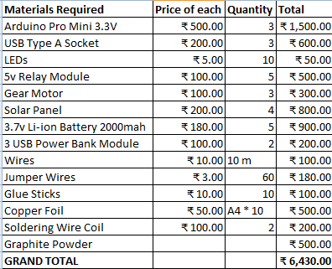
MATERIALS REQUIRED | PRICE OF EACH | QUANTITY | TOTAL
Arduino Pro Mini 3.3V | ₹‎500 | 3 | ₹‎1,500
USB Type A Socket | ₹200 | 3

This will help us plan our budget and ensure that our students have all the necessary resources to excel in the competition.
Thank you for your attention to this matter. We look forward to your prompt response and support in making this event a success for us.

Yours sincerely
SWARNADEEP MUKHERJEE (10 J)
ANISH DE (10 F)

